Sproughton Listed Buildings – Nov 2020
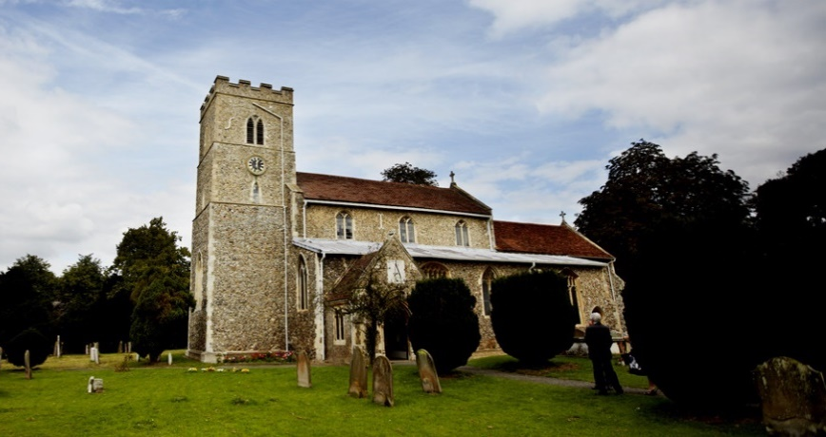

Grade II*
- Church of All Saints, Sproughton, Babergh, Suffolk, IP8

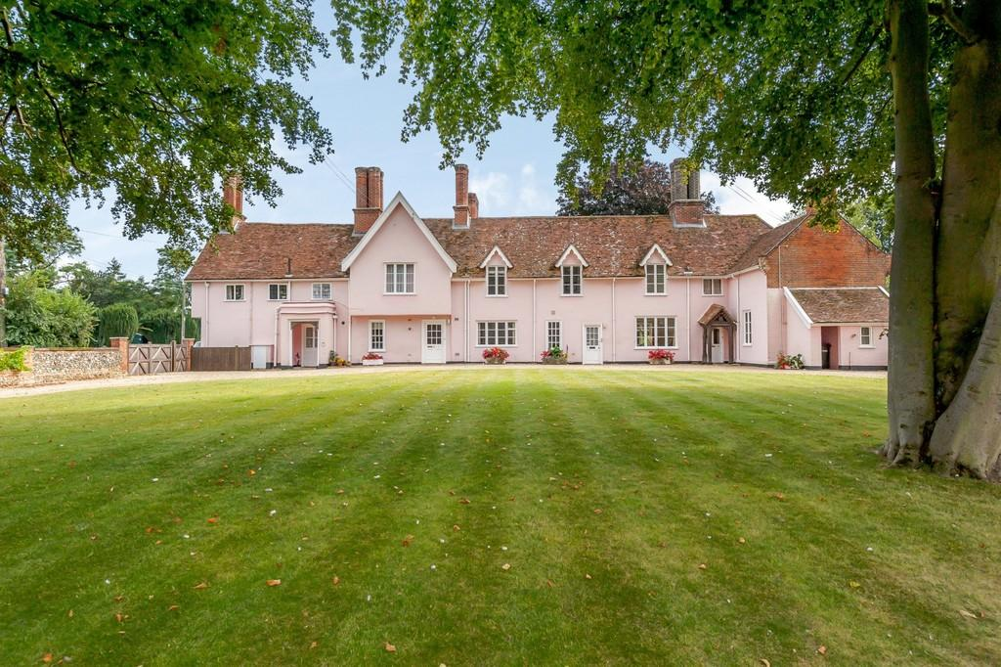

Grade II
- 1-4, Church Close, Sproughton, Babergh, Suffolk, IP8

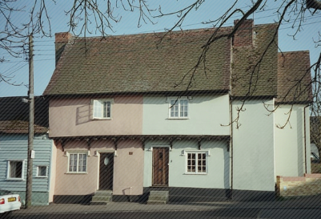
- 2 and 4, Lower Street, Sproughton, Babergh, Suffolk, IP8

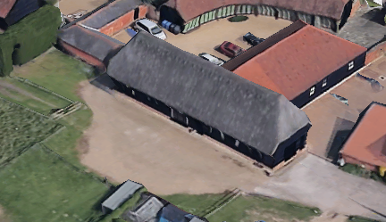
- Barn About 50 Metres South West of Sproughton Hall, Sproughton, Babergh, Suffolk, IP8

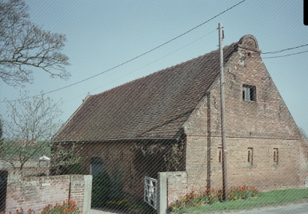
- Barn Circa 20 Metres South East of Red House, Sproughton, Babergh, Suffolk, IP8

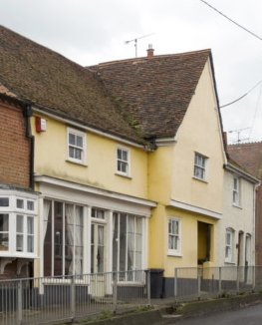
- Lower House and the Stores, Sproughton, Babergh, Suffolk, IP8

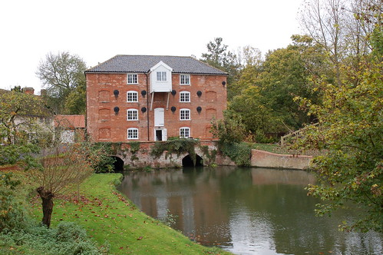
- Mill, Sproughton, Babergh, Suffolk, IP8

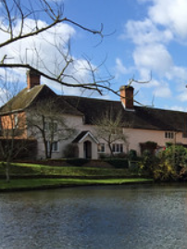
- Mill House, Sproughton, Babergh, Suffolk, IP8

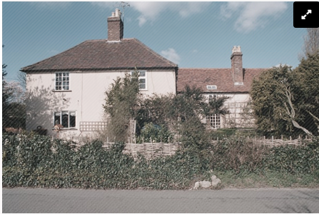
- Poplar Farmhouse, Sproughton, Babergh, Suffolk, IP8

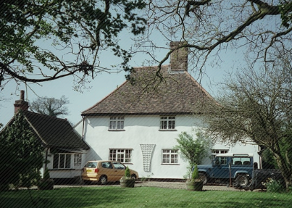
- Prync's Lodge, Sproughton, Babergh, Suffolk, IP8

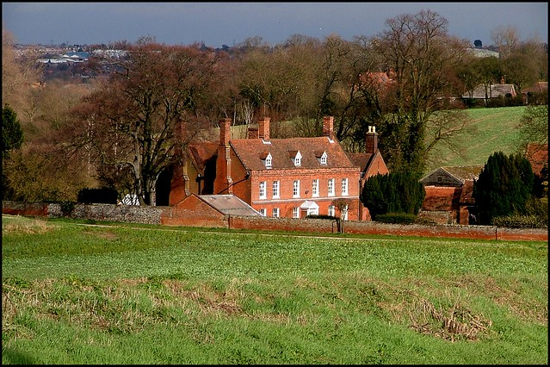
- Red House, Sproughton, Babergh, Suffolk, IP8

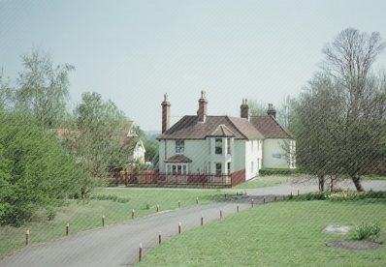
- Springvale, Sproughton, Babergh, Suffolk, IP8

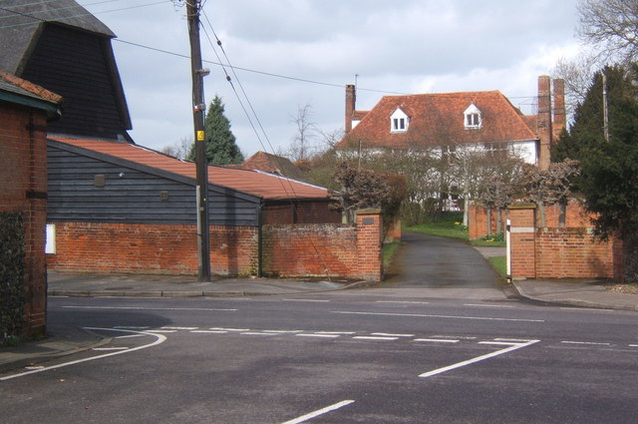
- Sproughton Hall, Sproughton, Babergh, Suffolk, IP8

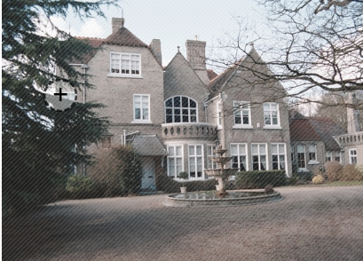
- Sproughton Manor, Sproughton, Babergh, Suffolk, IP8

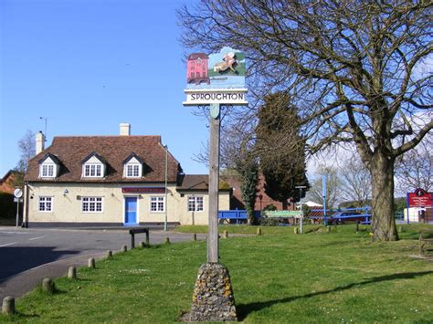
- The Wild Man Pub, Sproughton, Babergh, Suffolk, IP8

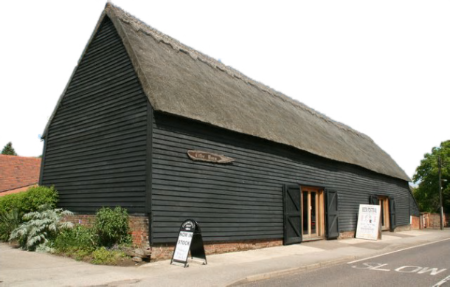
- Tithe Barn, Sproughton, Babergh, Suffolk, IP8

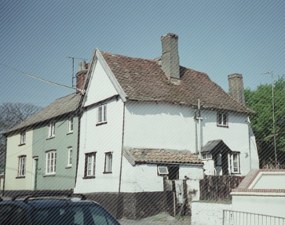
- Walnut Cottage, Sproughton, Babergh, Suffolk, IP8

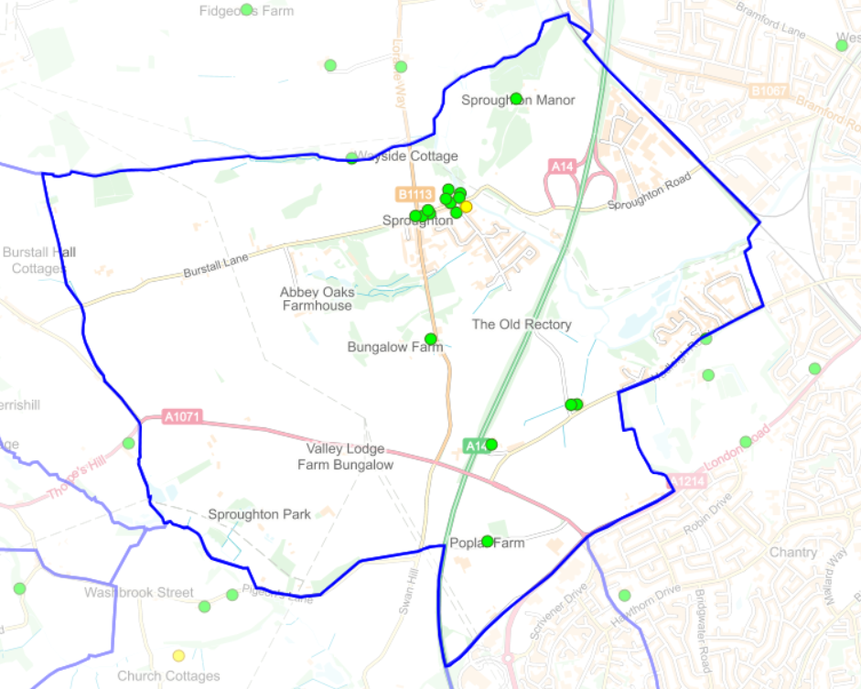
Parish Overview Village Overview
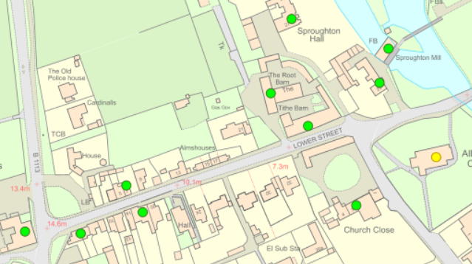

Appendix
https://historicengland.org.uk/sitesearch?search=sproughton
https://britishlistedbuildings.co.uk/search/?q=sproughton#.X60xBFpxdPY
https://historicengland.org.uk/listing/the-list/map-search?clearresults=True/

Complied by Rhona Jermyn
Chair Sproughton Neighbourhood Plan.
November 2020

